ORIENTAL RUG SOCIETY OF NSW

25A Creek St, Forest Lodge NSW 2037 www.rugsociety.org.au
 www.facebook.com/orsnsw
Vol 44 No 2

NEXT MEETING

Tuesday, 18 March 2025
7.00 PM: Refreshments
7.30: Talk
National Trust Centre,
Observatory Hill
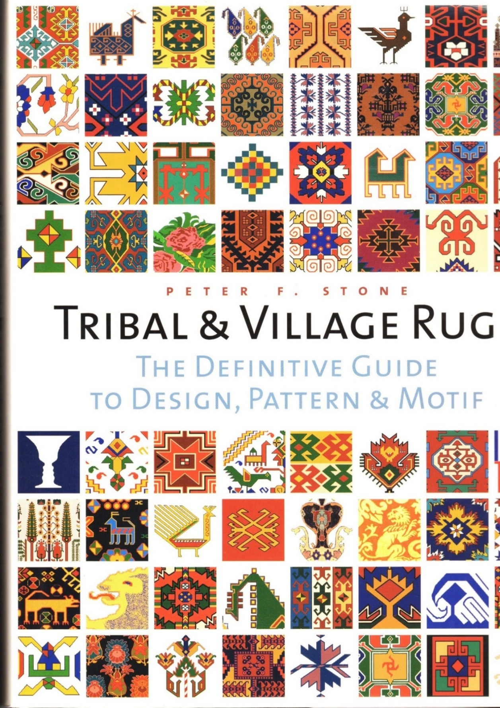

Talk: Fez & Kilim

There’s still room left at our 18 March meeting (a Tuesday, please note) at which well-known figure and speaker in the oriental rug world, Peter Bichler, will give us a well-illustrated presentation titled Fez & Kilim.
Peter will explain features of the commercial trade (including rugs) between the Ottoman and Austro-Hungarian Empires, including the “kilim-mania” triggered by the 1873 Vienna World Fair.
As well as being President of the Austrian Society for Textile Art Research, Peter has organised rug exhibitions and catalogues and delivered lectures in various European centres.
As always, our caterers ask you to please RSVP to info@rugsociety.org.au as soon as possible; we’ve acknowledged all confirmations so far.

Entry, $20 members, $30 guests. Pay by cash or card on the night, or pre-pay by electronic transfer to: Oriental Rug Soc. of NSW
BSB: 062 217 Acct no: 10491173
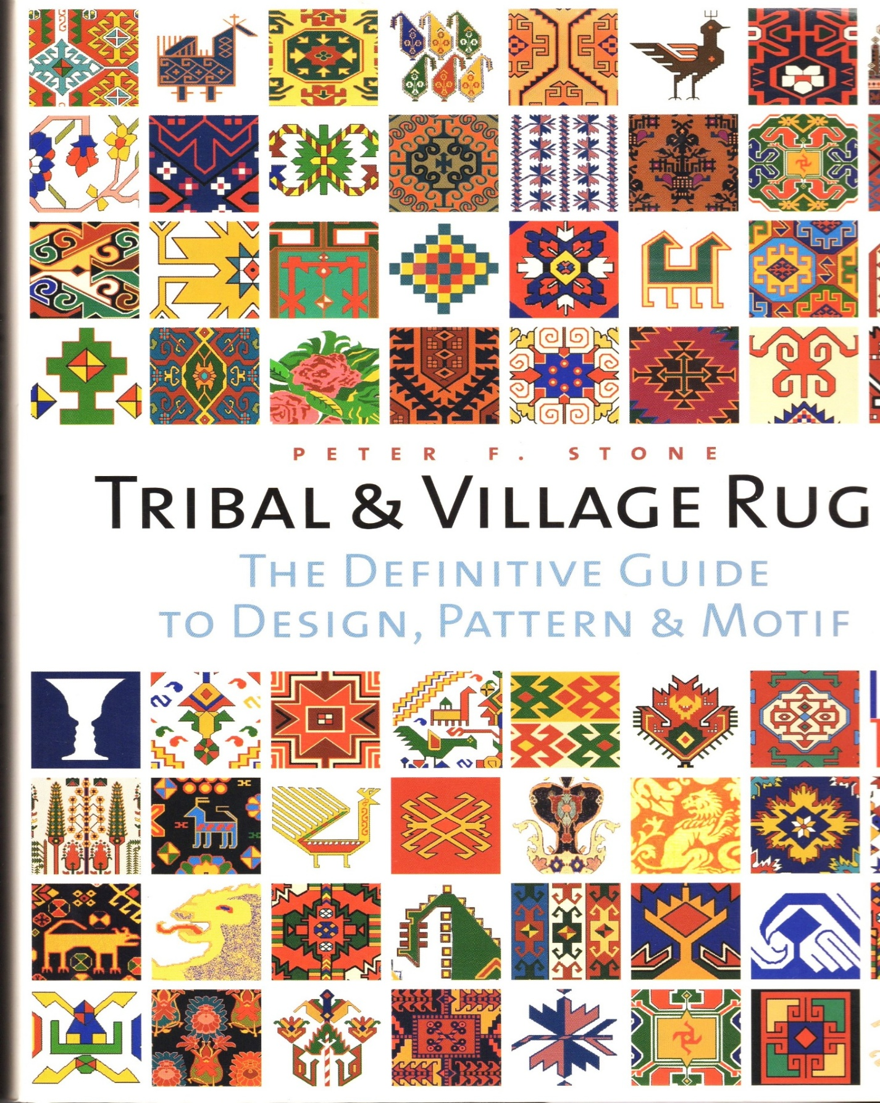
Meeting Dates for 2025

Tue 18 Mar, Thu 12 Jun, Tue 5 Aug
Thu 9 Oct, Sun 7 Dec (TBC)

Membership Renewals for 2025

Please remember to renew your ORS membership for 2025 if you haven’t already. Simply transfer $45 for single members, $55 for couples to our account, above. In the Ref/Description, give your surname & ‘Sub’. Then please email ruthlarner@gmail.com with your full name, how much you paid and when.
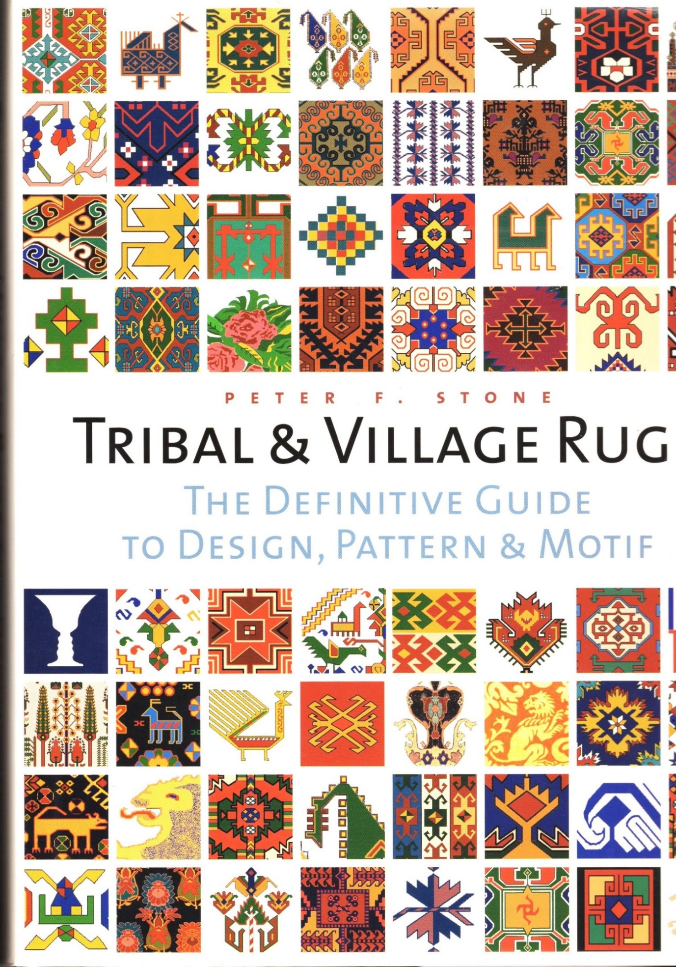
Last Meeting

Our Annual General Meeting resulted in the election of the following:
President: Leigh Mackay
Deputy President: Gail Broadbent
Treasurer: Ruth Larner
Secretary: Ian Perryman
Committee: Annette Gero, Pamela Leuzinger,
Christina Sumner.
Following the AGM, we relaxed with our annual (and typically eclectic) Show & Tell by members, including regular American visitors from the New England Rug Society in Boston, Joel and Cheryl Greifinger. Below is a selection of our members’ offerings.

ORS Show & Tell, February 2025
First, some Southwest Persian bag faces that Ross brought for the show.

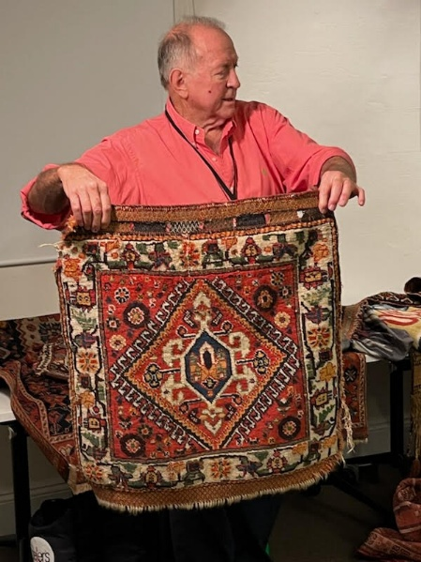

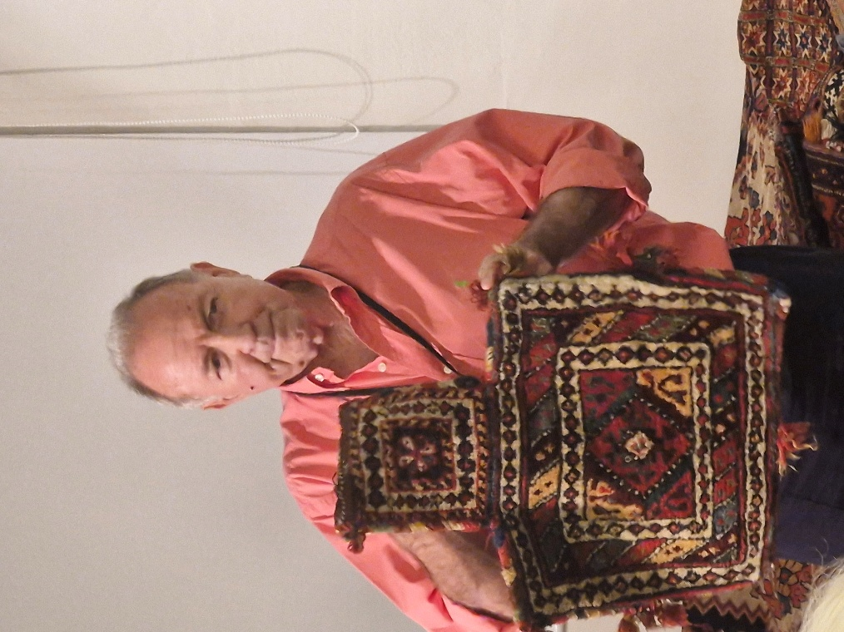

A colourful salt bag of the Luri people.
Woolen pile face, flatwoven back. A pretty saddle or tent bag (Khorjin).
Luri people, though with a Qashga’i
central medallion.

(Below) Pile Front and back of a small Qashga’i/Khamseh bag.
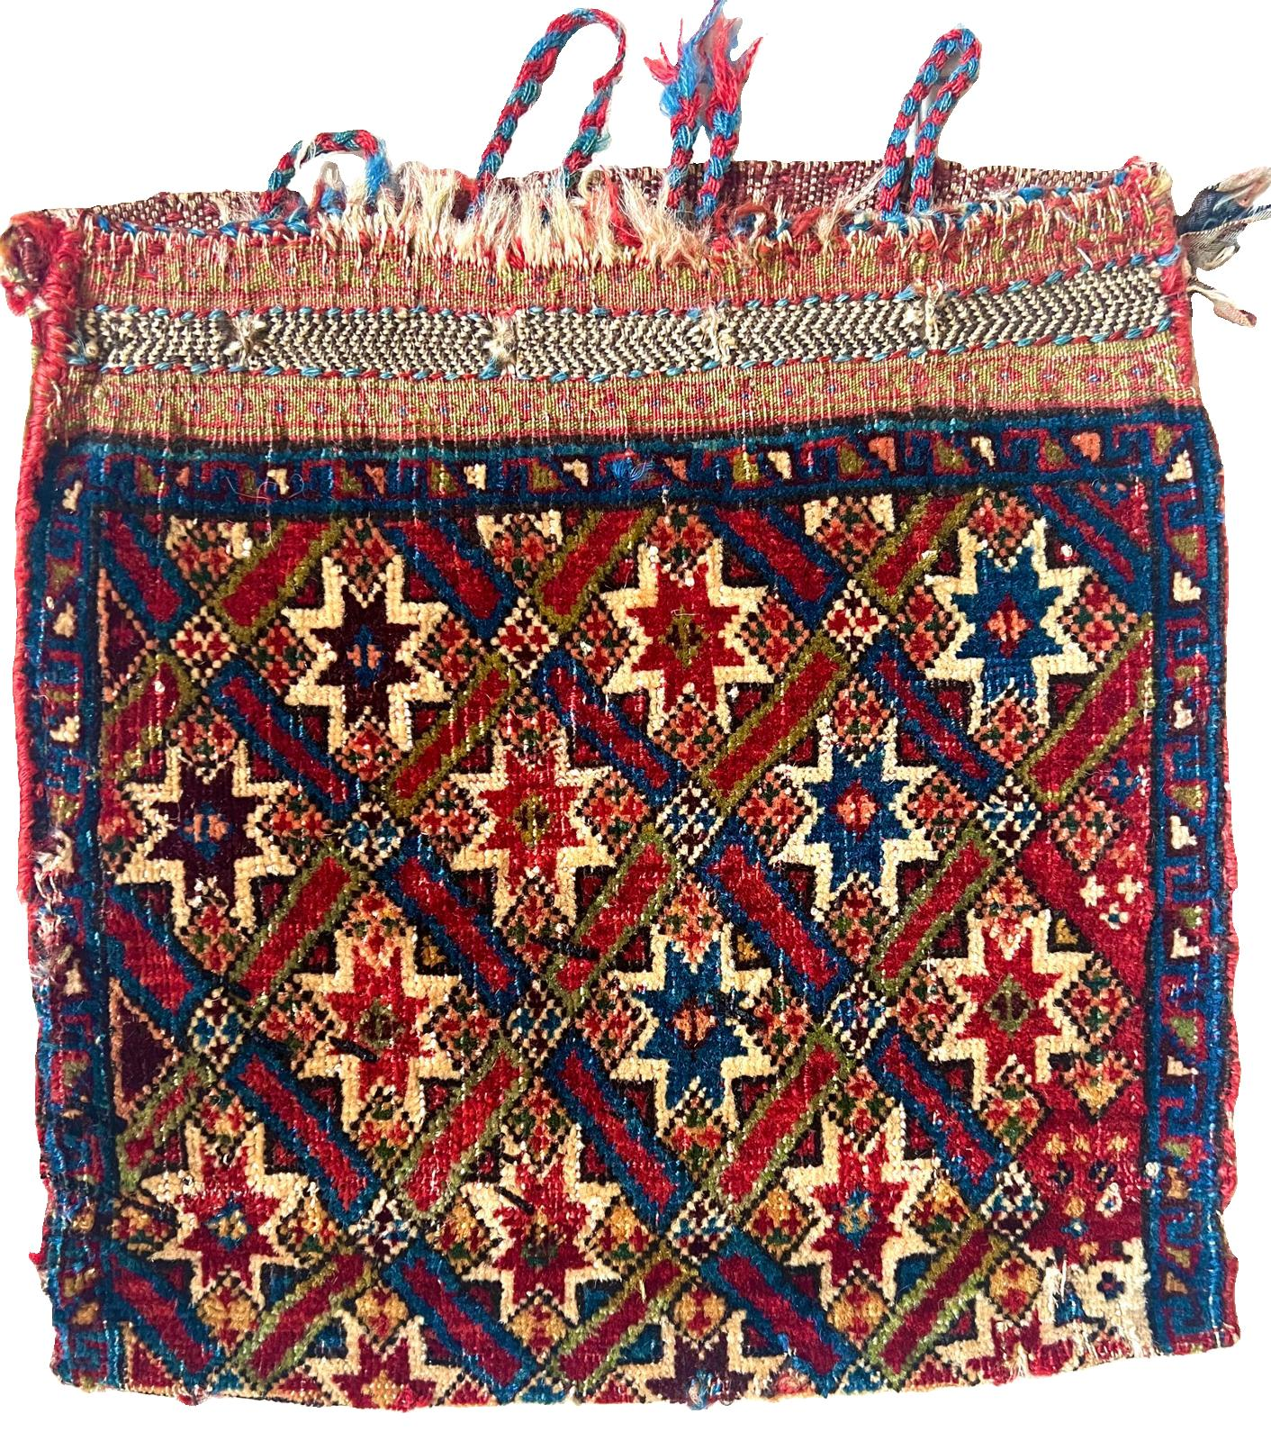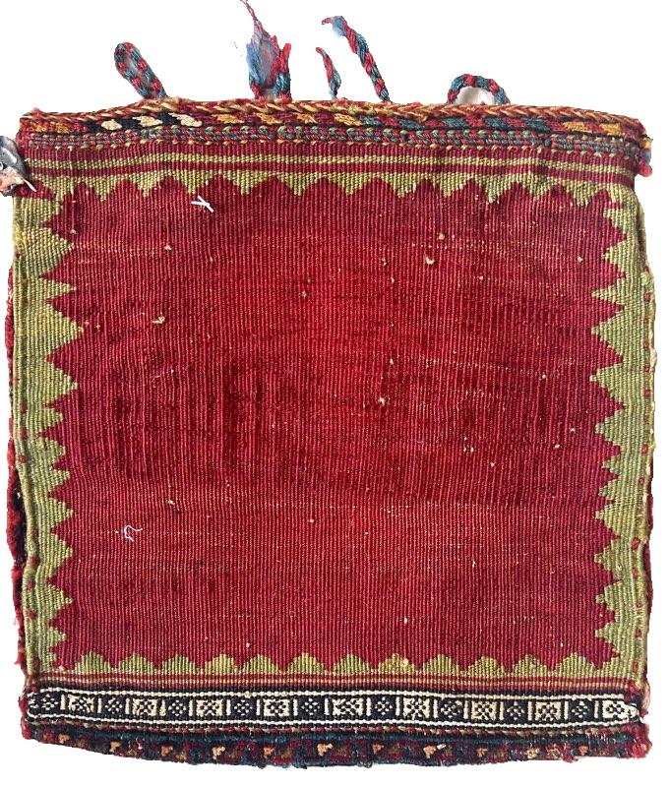

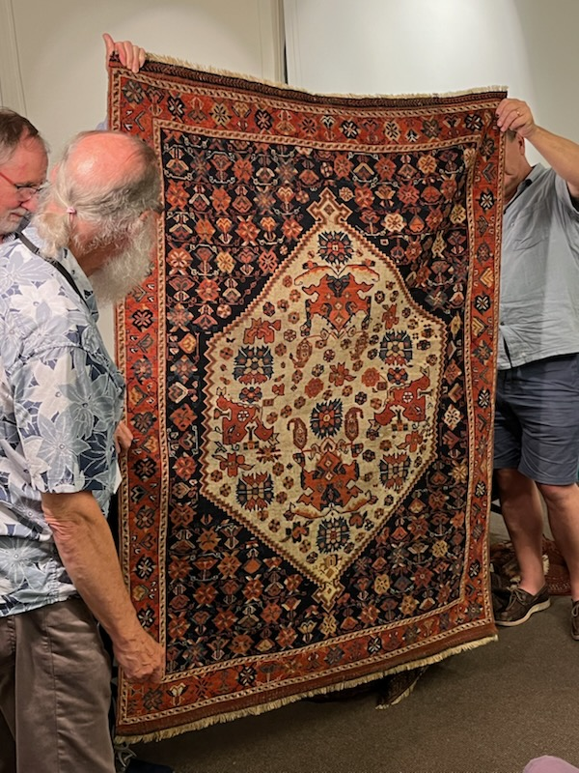
Joel discusses features of this Afshar rug,
with intricate pattern, from Southeast Iran.
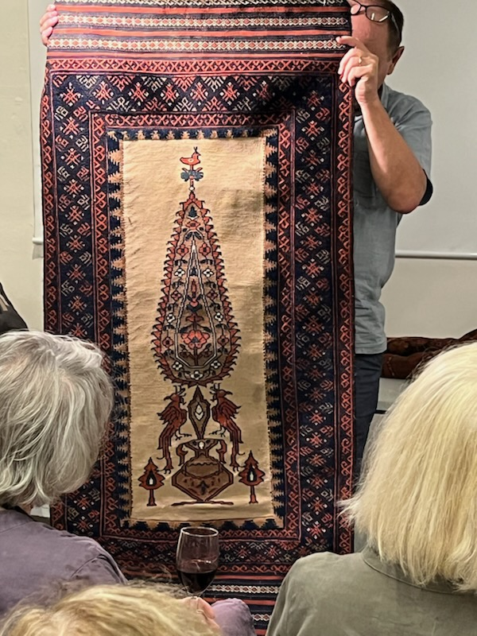

Annette’s Baluch Sofreh (spread on
ground for serving food). Kilim centre
(camel hair?), pile-woven borders.

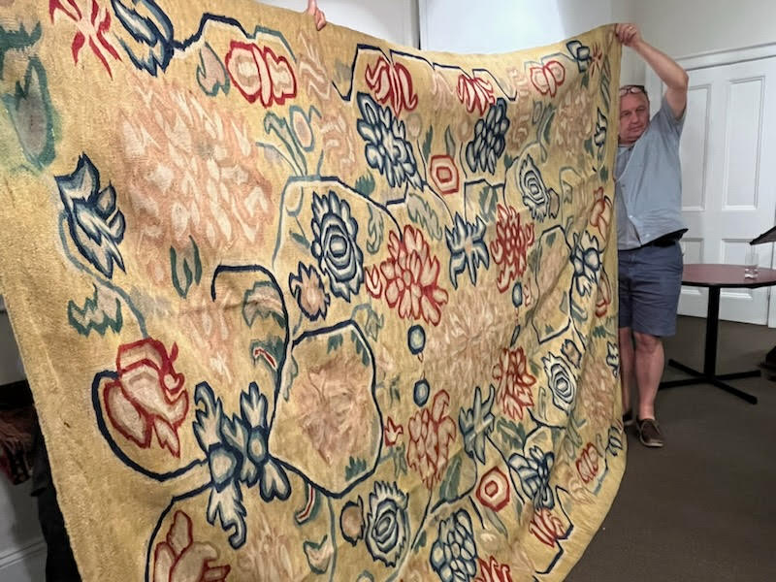

Ian with his attractive mid-19th century Bessarabian cover.
Bessarabia was roughly today’s Moldova.

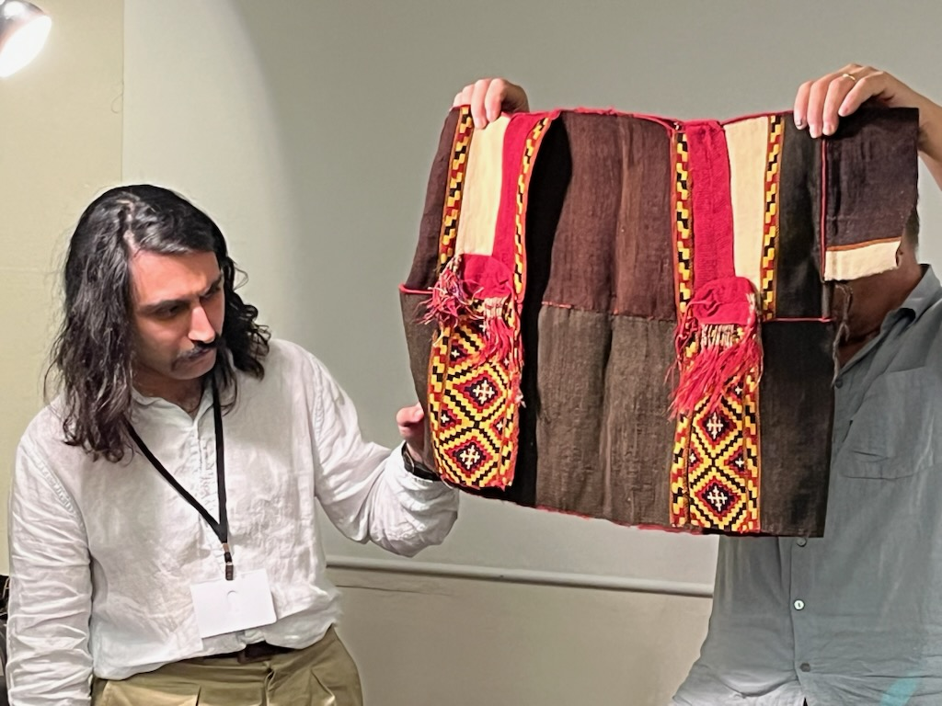
Bani showed this early 20th C. Assyrian clerical waistcoat, with kilim
panels, from Hakkari, southeastern Anatolia.

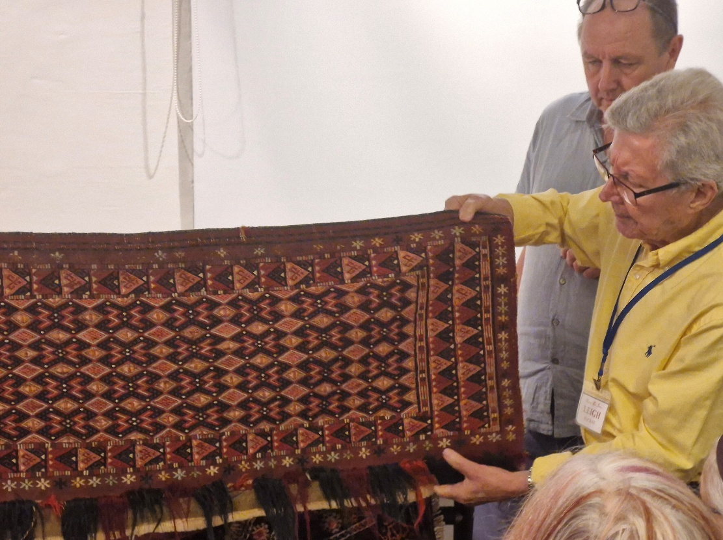
Leigh with a Torba (tent bag) of the Ersari Turkmen of north
Afghanistan. Flat-woven in silk & wool.

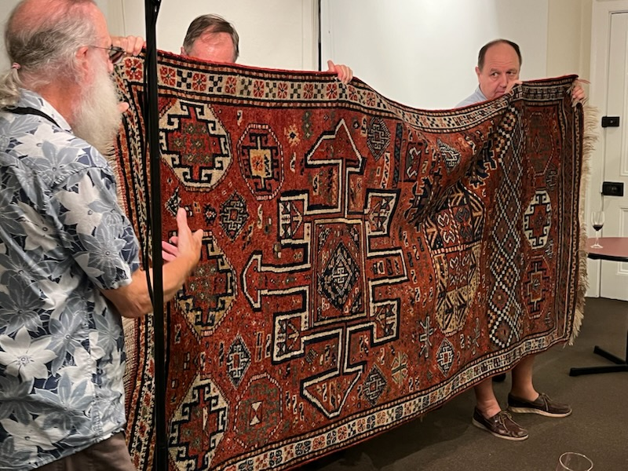
Joel & Ian with an eccentrically ornamented rug from Khurasan, north
eastern Iran, woven by Kurds (Kordi).

