ORIENTAL RUG SOCIETY OF NSW

25A Creek St, Forest Lodge 2037 NSW www.rugsociety.org.au
E: info@rugsociety.org.au www.facebook.com/orsnsw

Vol 45 No 3

NEXT MEETING

Thursday, 11 June, 2026
7.00 PM: Refreshments
7.30 PM: Textile Donations

ORS Donations to Powerhouse
Please join us on 11 June to view the striking and finely crafted textiles the ORS is donating to the Powerhouse collection.
The products of a long and meticulous search by a specially-appointed sub-committee, these textiles of various techniques and functions range from a dazzling 19th C. Central Asian suzani to fine and decorative dhurries woven in Indian jails
While the Powerhouse collection attempts to represent the various regions, techniques and purposes that compose the world of oriental rugs and textiles, it unavoidably contains several gaps, notably India and Tibet.
As agreed at previous ORS meetings, we’ve drawn on the society’s accumulated funds to fill those gaps and further enhance the collections with some high quality pieces. We’re delighted to report the Powerhouse has enthusiastically accepted our five choices.
A senior curatorial executive has praised them a “beautiful and important addition to the (Powerhouse’s) Asian arts collection.”
We think our members will agree when we display them, with a short talk on each, on 11 June!

Our venue as usual is the National Trust Centre, Observatory Hill. We with refreshments at 7.00pm. If you haven’t already confirmed, please do so ASAP to: info@rugsociety.org.au

Entry, $25 members, $35 guests. You may
pay by cash or card on the night, or pre-pay
by electronic transfer to:
Oriental Rug Soc. of NSW, BSB: 062 217
Acct no: 10491173
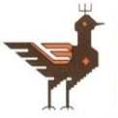

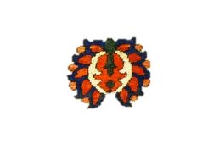
Meeting Dates for 2026

Apr 16, Jun 11, Aug 13, Oct 8, Dec 6

Last Meeting
All Executive positions (President, Deputy President, Secretary, Treasurer), and Committee positions fall vacant (see attached Agenda).



